Introduction to the Student Learning Experience (SLE) model #3

Summary Paper
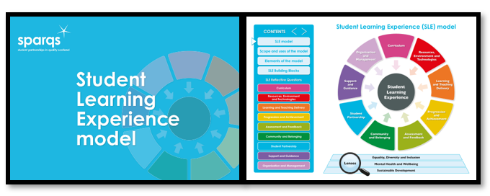

Introduction
This summary paper is intended to provide an overview of the Student Learning Experience (SLE) model (2023) from sparqs.

Why do I need to know about this?
The SLE model is a sector-wide reference point which underpins Scotland’s shared emphasis on a student-centred approach, and the importance of working in partnership to enhance learning and teaching practices within tertiary education. The SLE model helps us to break down the holistic student learning experience into important building blocks in a way that allows us to use common language and understanding. It aids our reflective practice in the context of Scotland’s Tertiary Quality Enhancement Framework (TQEF), which are the quality arrangements for Scottish colleges and universities. The model also maps onto relevant professional standards for colleagues working in Scottish tertiary institutions, and can help support our professional development. Finally, but crucially, it provides a framework for genuine dialogue with our students.

Links with Tertiary Quality Enhancement Framework (TQEF)
The TQEF is founded on a set of six shared principles (see Fig 1) that have been used to shape its development, and which underpin and permeate every aspect of the framework. The six principles are Enhancement and Quality Culture; Externality; Data and evidence; Student engagement and partnership; Supporting student success; and Excellence in learning, teaching and assessment.
At the core of these shared principles is the desire to deliver better outcomes for our students, and to place them at the heart of the framework.

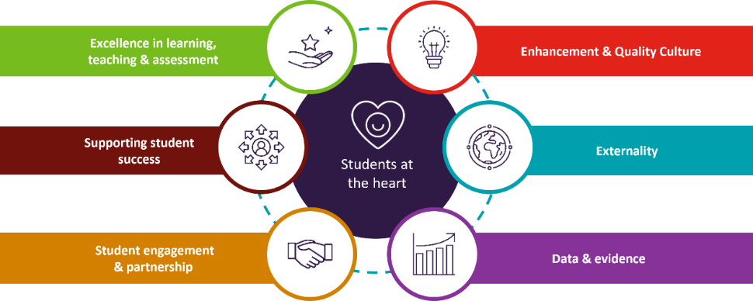
Fig 1: Principles of Scotland’s Tertiary Quality Enhancement Framework (TQEF)

The SLE model was developed to underpin the TQEF principle of Student engagement and partnership, but it also plays a role in two other principles, namely ‘Supporting student success’ and ‘Excellence in learning, teaching and assessment’.

How was the SLE model developed?
The SLE model was an existing tool that sparqs has used with Course Reps for more than a decade to support their understanding of different elements that make up the holistic concept of the student learning experience.​ Important features to be aware of for the 2023 version are that it was founded on the views of students across Scotland on what makes an excellent quality learning experience, and this was achieved by co-creating it with more than 300 students who represented 36 Scottish tertiary institutions.
Key stages in its development included desk-based research and sector benchmarking to update the existing model using existing reference points. This was then followed by a series of national workshops; establishing a Student and Staff Advisory Group; and dialogue with various sector committees in Scotland.

What is the SLE model?
The SLE model (see Fig 2) can be used across a range of diverse learner journeys and is intended to support the provision of a high-quality learning experience to all students, however and wherever they learn.
The model comprises 9 building blocks which are shown in the coloured sections in Fig 2. Each building block represents a key element of the Student Learning Experience, and helps to break this down into practical, bite-sized chunks which can then be explored and discussed by students and staff using partnership approaches.
The model also has 3 lenses which can be applied to each building block, namely Equality, Diversity and Inclusion​ (EDI); Mental Health and Wellbeing​; and Sustainable Development.

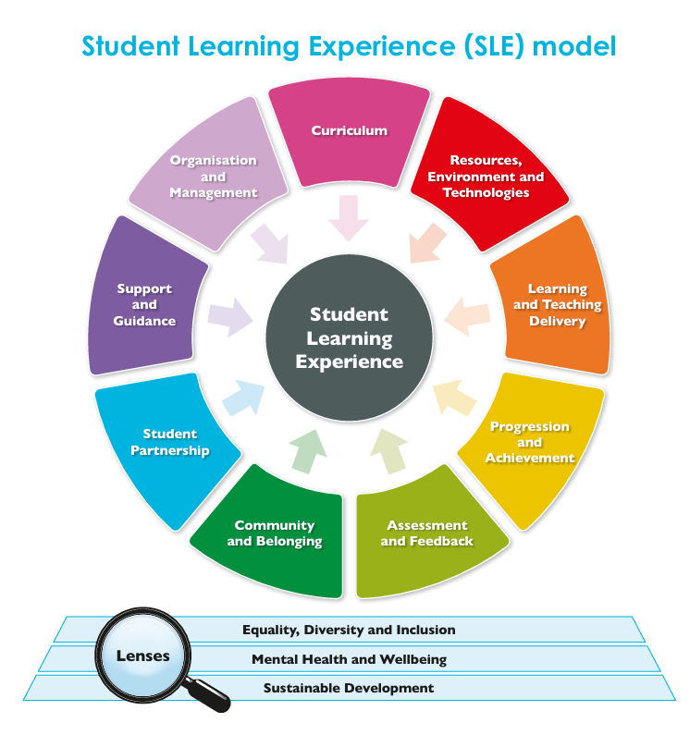

Fig 2: Student Learning Experience (SLE) model, 2023

The 9 SLE building blocks also map to key principles within the Tertiary Quality Enhancement Framework, namely, ‘Excellence in learning, teaching and assessment’, ‘Supporting student success’, and ‘Student engagement and partnership’ (see Fig 3).

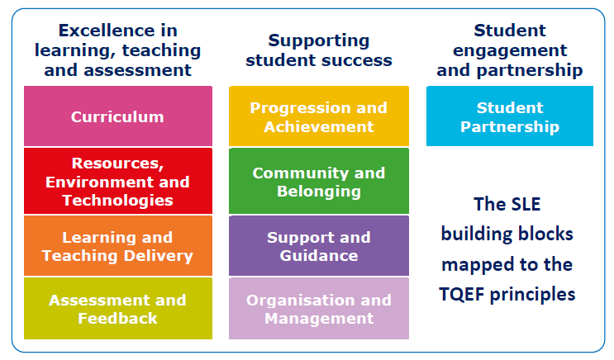

Fig 3: SLE model Building Blocks mapped to TQEF Principles

Finally, in terms of the content of the SLE model, each building block has an accompanying set of 10 reflective questions, which can be used to develop an understanding of both strengths and areas for future enhancement. These can be found within the SLE model resource.

How should/could the resource be used?
The SLE model is not intended to be a checklist, but it is a key sector reference point within the TQEF. It plays a role in supporting institutions with their Self-Evaluation and Action Plan (SEAP), and in preparing for institutional Tertiary Quality Enhancement Review (TQER) visits.

It’s also a practical tool that has other potential uses for individuals, programme teams, institutions and students’ associations. It can play a key role in promoting and supporting dialogue between staff and students, particularly during staff-student meetings. It’s also an excellent tool for prompting reflection and enhancement planning, either as part of annual quality and course review processes, or as a key element within staff development activities. You can see further potential uses within the SLE model itself, and we’ll be capturing other uses in case studies from a variety of Scottish tertiary institutions, so keep a look out for those.

Acronyms

- EDI = Equality, Diversity and Inclusion
- SEAP = Self-Evaluation and Action Plan
- SFC = Scottish Funding Council
- SLE = Student Learning Experience (model)
- sparqs = student partnerships in quality Scotland
- TQEF = Tertiary Quality Enhancement Framework
- TQER = Tertiary Quality Enhancement Review

You might also find our sparqs Acronym Buster helpful as you navigate terminology within the Scottish tertiary sector.

Mapping to Professional Standards
Professional Standards for Lecturers in Scotland’s Colleges (GTCS):
1.1.1/2/3/4, 1.2.3, 1.3.2/5, 2.1.1/3/4, 2.2.1/2/3/4/5/12, 2.5.2/4/6, 3.2.1/2/3/4, 3.33

Professional Standards Framework 2023 (PSF 2023) (Advance HE):
V1, V2, V5, K2, K5, A1, A2, A4.

Copyright

Licensed under a Creative Commons Attribution Non-commercial 4.0 licence.
You are free to copy, communicate and adapt the work, so long as you attribute sparqs.

_______________________________________________________________________________

Who are sparqs?
sparqs stands for ‘student partnerships in quality Scotland’.

We’re a Scottish sector agency and charity, with full-time staff based in Edinburgh. We work with students and staff in all institutions and students’ associations across the Scottish university and college sector, and our main funding comes from the Scottish Funding Council (SFC). You can find out more about us through our website.

Contact us
If you have questions or would like to provide feedback on this resource (or other resources within the Academic Development Toolkit) please don’t hesitate to get in touch with Prof Catriona Bell, sparqs External Consultant – catriona.bell@sparqs.ac.uk

